LOK SIN TONG YEUNG CHUNG MING PRIMARY SCHOOL
English Self Learning Worksheet ( 1 )
Class:4( ) Date:_______________________
Name:__________________________ ( ) Grade:_____________________
Reading Skill: extracting main ideas
May and Sam will visit Hong Kong next week. They are looking at their plans.
Things we will do next week
Date | Place to visit | Activities
Monday | Lantau Island | - ride on the cable car  - have a vegetarian lunch  - visit the Big Buddha in Ngong Ping  - go shopping in a shopping centre in Tung Chung
Tuesday | Sai Kung | - go swimming and do water sports at Clear Water Bay  - have a seafood dinner
Wednesday | The Peak | - take the Peak tram to the Peak  - look at the view of Hong Kong  - buy gifts for family and friends
Thursday | Ocean Park | - go on exciting rides  - watch the dolphin show  - visit the penguins  - look at the pandas  - take photos of animals
Friday | Repulse Bay | - take photos and swim at the beach  - have a barbecue

Choose the best answer by blackening the circle.

1. On which day will Sam and May take their swimsuits?

○A. Monday and Tuesday ○B. Tuesday and Wednesday
○C. Wednesday and Friday ○D. Tuesday and Friday
2. Which of the following will the children eat in Ngong Ping? (You may choose
more than one answer)
○A. potato ○B. beef
○C. seafood ○D. tofu

3. Sam and May will eat _____ in the restaurant in Sai Kung.

○A. fish and crabs ○B. beef curry
○C. pork ribs ○D. spaghetti with ham and cheese

4. What kind of transport will the children take to the Peak?

○A. bus ○B. tram
○C. ferry ○D. cable car

5. What will Sam and May do next Monday? Write 1–4 to put the pictures in the
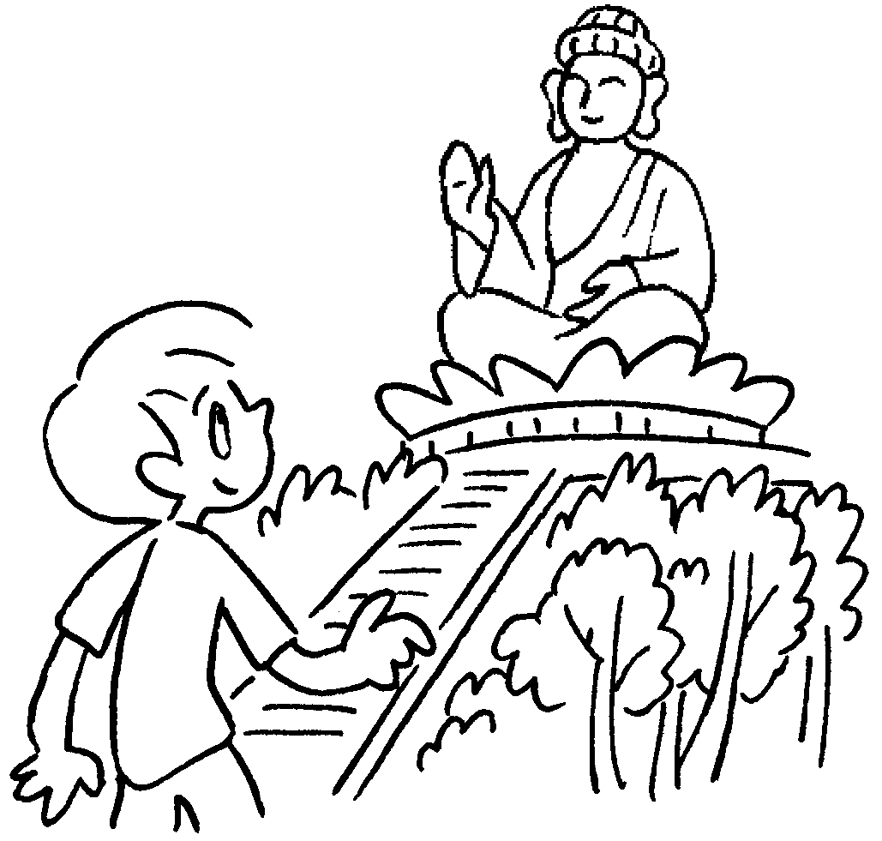
correct order.
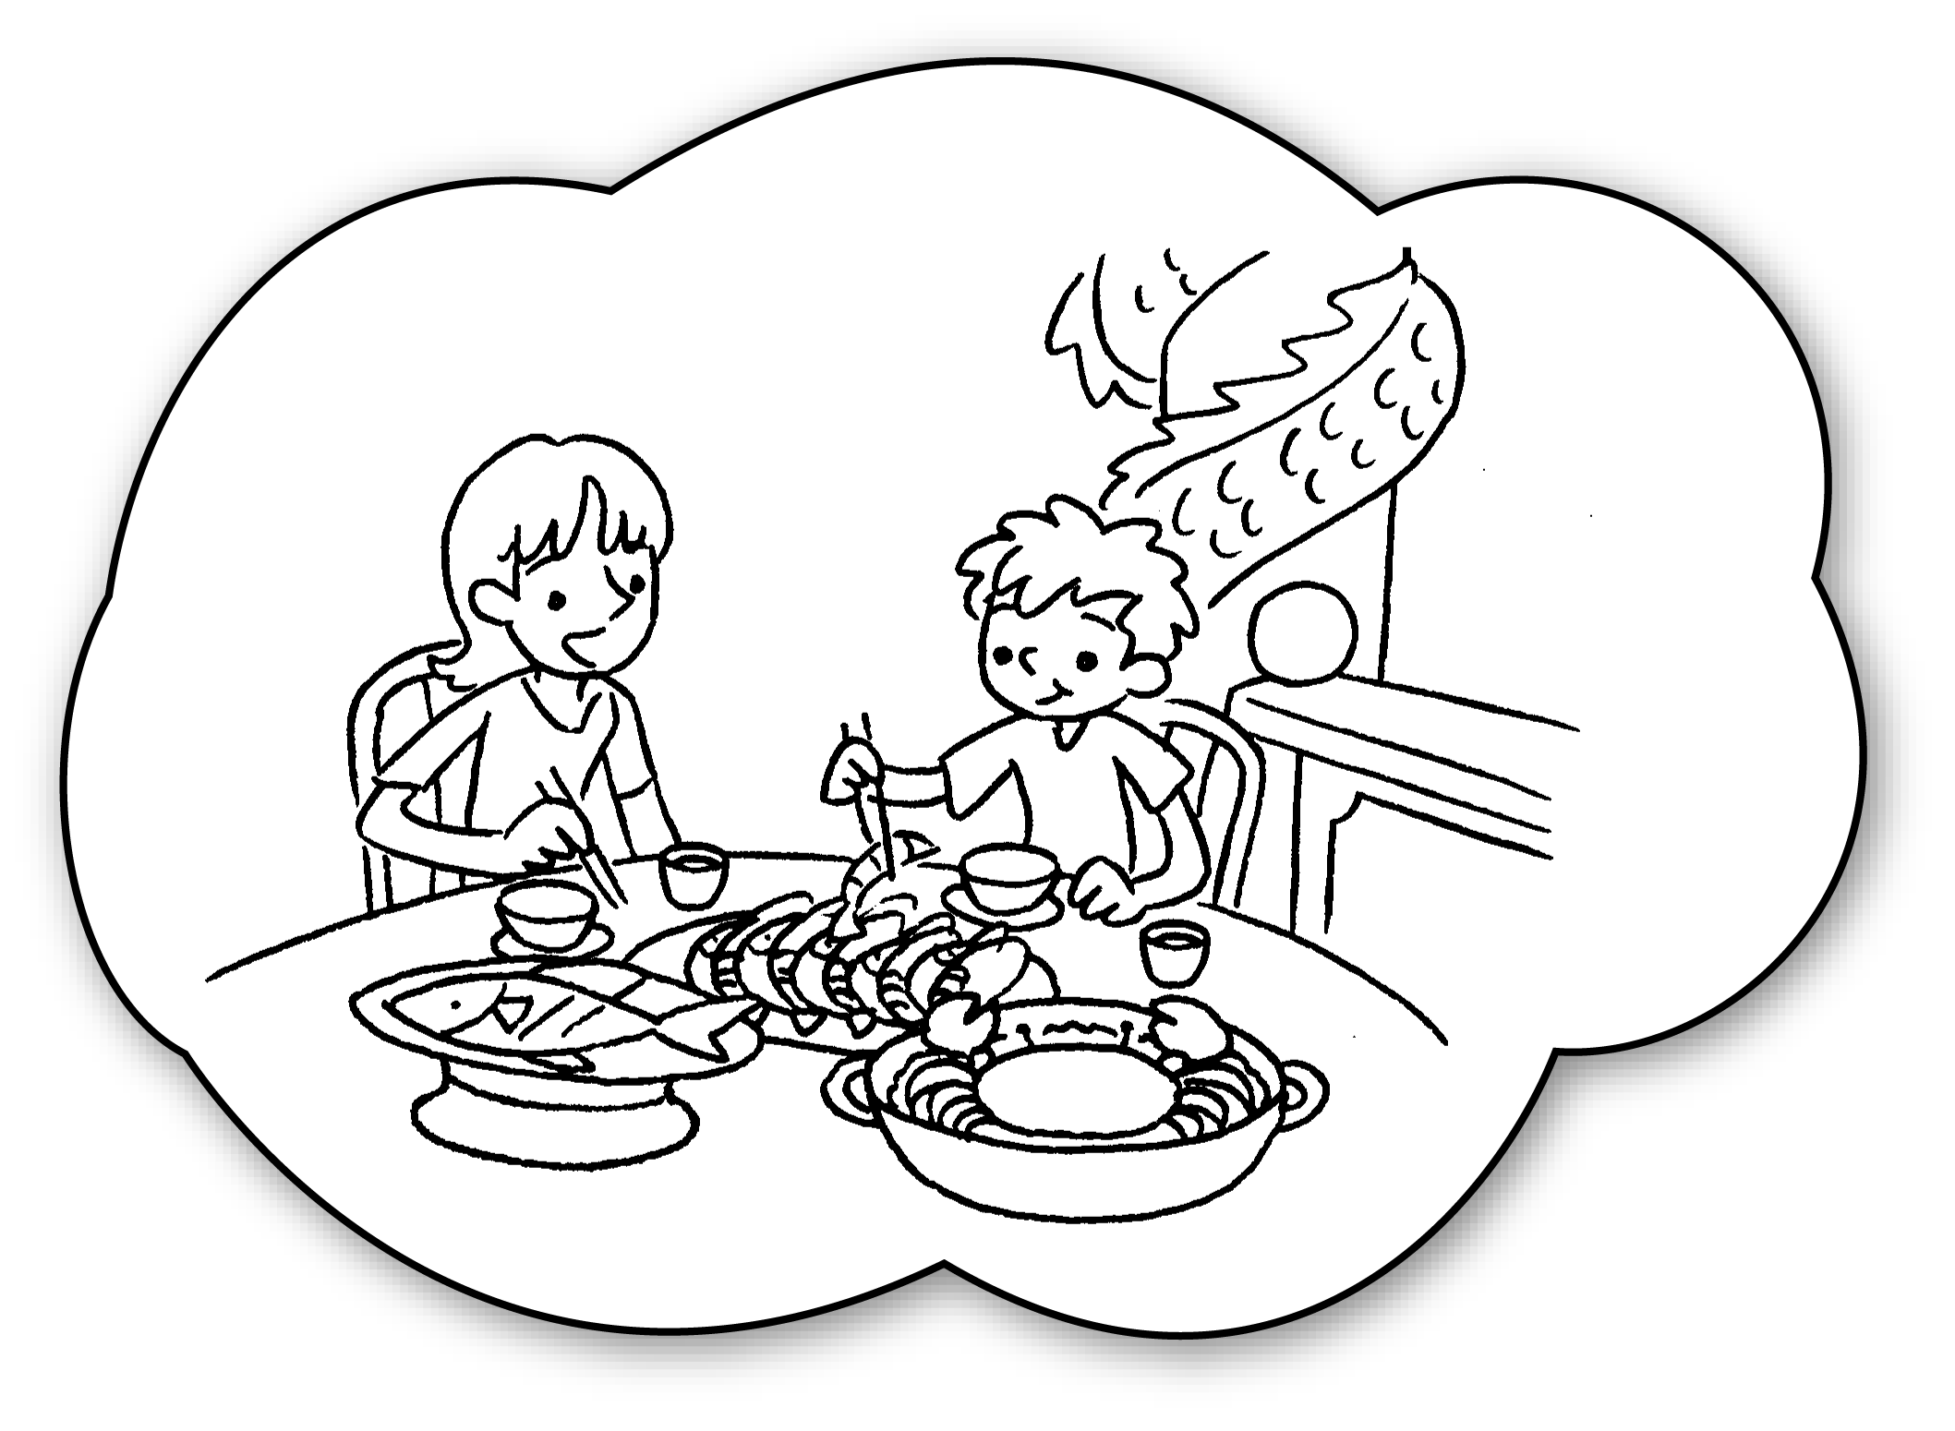 | 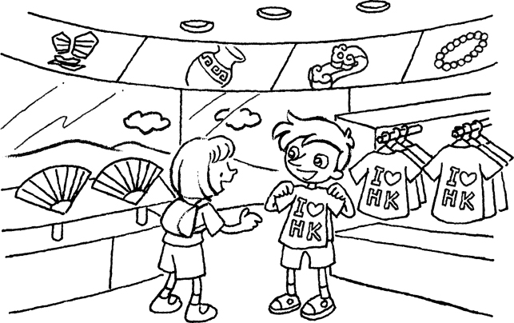 |  | 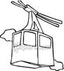
A. | B. | C. |  | D.

Answer the question in complete sentences.
6. Where would you like to visit in Hong Kong? Why?

_______________________________________________________________

_______________________________________________________________

7. May is writing about a journal entry. Read the article on P.1 and help her finish the writing. Use with only ONE word for each blank.
Last week, I visited Hong Kong with my friend Sam. We went to Aberdeen to have a i)_____________ lunch on the first day. The fish was very fresh and delicious. Then we went ii) _____________ in Tsim Sha Tsui. We bought a lot of clothes and toys. It was a wonderful day.

